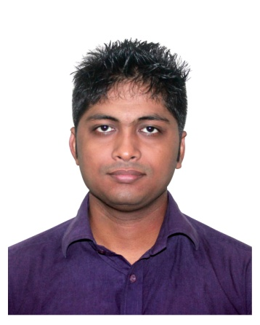

**AKBAR AZAD**

**P-15, Noorjahan Road, Mohammadpur, Dhaka-1207**

**Mobile No: +880 1674 870420**

**Email: akbarazad1111@gmail.com**

# Career Objective

**To pursue career in a dynamic and renowned organization where I can my enthusiasm to achieve the very best possible for the organization and for myself. I want to be a trendsetter in my arena.**

# Areas of Strength

* **Good interpersonal and communication skills.**
* **Ability to adapt to new environment and willingness to learn.**
* **Hardworking under pressure, loyal and honest.**
* **Self motivated and ambitious with a strong desire to succeed.**

# Educational Qualification

1. **Bachelor of Social Science (B.S.S)**

**University : Bangladesh Open University.**

**Subject : Sociology**

**Running 4th semester.**

1. **Higher Secondary School Certificate (H.S.C)**

**Name of the Institute : Dhaka Residential Model College.**

**Name of the Department : Science.**

**Name of the Board : Dhaka.**

**Year of Passing : 2009**

**GPA : 5.00 (Out of 5.00)**

**c) Secondary School Certificate (S.S.C)**

**Name of the Institute : Dhaka Residential Model College.**

**Name of the Department : Science.**

**Name of the Board : Dhaka.**

**Year of Passing : 2007**

**GPA : 4.88 (Out of 5.00)**

1. **I have been worked as a ‘Brand Promoter’ at Laborvoice from 3rd February, 2017 to 24th November, 2017.**
2. **I have been working as a ‘Sales Associate’ at Grameen Uniqlo from 7th December, 2017 to till now.**

# Experience

* **Computer Awareness in Basic**.
* **Team work**.

# Additional Qualification

* **Management skills.**
* **Quick response in any situation.**

# Computer Skill

* **Package Program : Microsoft Office (Word, Photoshop, Illustrator)**
* **Internet : Net Browsing, Email (including all).**

# Language Skills

**[**

**Bengali : Reading, Writing, Speaking & Understanding – Excellent**

**English : Reading, Writing, Speaking & Understanding – Good**

# Personal Information

**Name : Akbar Azad**

**Father’s Name : Abul Kasem Azad**

**Mother’s Name : Morjina Azad**

**Permanent Address : Vill : Ramnagar, P/O: Godagari-6290,**

**P/S : Godagari, Dist : Rajshahi.**

**Present Address : P-15, Noorjahan Road, Mohammadpur, Dhaka-1207.**

**Nationality : Bangladeshi.**

**Date of Birth : July 26, 1991.**

**Place of Birth : Rajshahi**

**Martial Status : Unmarried**

**Sex : Male**

**Religion : Islam**

**Blood Group : O+**

**Height : 5 ft 9 inch**

**National ID No : 8658956183**

**I assure you to provide all the best service at all time. I hereby certify that above information is true and correct to the best of my knowledge and belief.**

**With my best Regards**

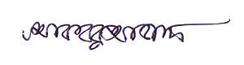

**Akbar Azad**